INFORMATION SHEET AGE 11-15

If you don’t understand a word in bold letters, check the boxes on the right for more info !

UK Histiocytosis Registry
What is histiocytosis?
Histiocytes are cells that help you to fight infections like coughs and colds and are found all over the body. People with ‘histiocytosis’ have too many of these cells and it makes them ill.
We are asking if you would like join a research project called the UK Histiocytosis Registry (UKHR).

We want find out more about illnesses like histiocytosis. A good way to do this is to collect up medical information and samples from lots of people like you into a Registry. About 500–1,000 children and adults in the UK have histiocytosis, and we will be inviting as many as we can to join the registry.
What is a Registry?
A registry is a bit like the register that your teacher calls out at school. It is a list of people with information about them. Another word to describe it is a ‘database’. If we collect lots of information about lots of people then we can find out exactly what happens in an illness.

This leaflet tells you about the Histiocytosis Registry so that you can decide if you want to join. Talk to you family and friends if you like. Ask us if there is anything that you don’t understand. Thank you for reading this.

Why are we making the UK Histiocytosis Registry?
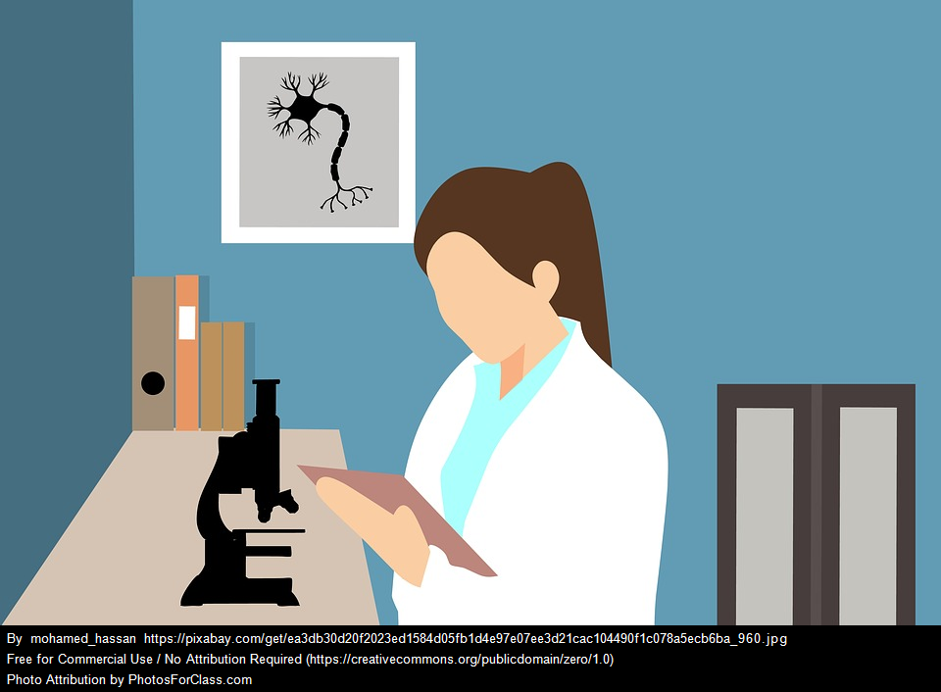
The UK Histiocytosis Registry might help to:
- Figure out exactly what causes histiocytosis
- Make treatments work better
- Find out more about how the illness affects you
- Get the right help for people with the illness

Why have I been chosen?
You have been chosen because the doctors think that you have histiocytosis or a related illness. Maybe you are about to have an operation called a ‘biopsy’ to find out exactly what is going on in your body.
What is a biopsy?
A biopsy is a small bit of your body taken by doctors during an operation. It could be skin, lymph glands, bone marrow or even a tiny bit of an organ like the liver. Usually you are asleep When a biopsy is done. Biopsies are taken to the hospital laboratory where they are looked at under a microscope and special tests are done. Usually, this tells your doctors exactly what is going on. Afterwards, there is usually a bit of the biopsy left over that can be used for research.

Do I have to take part?
It is up to you and your parents or guardian to decide whether or not to take part. If everyone agrees then we will go ahead. If you don’t want to join in then no problem. Everyone will still look after you just the same. It is up to you to join in or not. We may also contact you in the future but you can also stop any time if you want to.

What will happen to me if I take part?
A doctor or nurse will ask you to sign an agreement form (called an assent form) to say that you are happy to join in. If you join the Registry then we will write down information about you from your medical records. We may ask you to answer a quiz about how you feel and how your illness has affected you. We will also use any biopsies that the doctors take from you when you have an operation. If the doctors need to take some blood from you, then we may also ask for an extra bit of the blood. We will take up to 40ml or 2 tablespoons, depending on your age and size.

What happens to the information and samples that I give?
We will write things in the Registry from your medical records, using a website. We will write down the year that you were born, whether you are a boy or a girl, your racial background and that you live in the UK. We will write down lots of things to do with your illness and the treatment that you have had. When we put information in the Registry, we will use an anonymous code. This means that other people cannot identify who you are from the information. Only the medical team looking after you will know who you are.
What are my medical records?
Your medical records are all of the writing that doctors and nurses do and all of the test results about you. Your medical record can be kept in a big folder or on an electronic database or both. The folder that is used when you are on a hospital ward is also called your ‘hospital notes’

What is an anonymous code?
Anonymous means ‘no name’. Instead of keeping your name, we will give you a code so that no-one can identify you. Your information will be anonymous. It is similar to when you make a username on a website and you choose a word that keeps your identity hidden. In the registry we will use a number.

Biopsy samples and blood samples will be sent to Newcastle University where the Registry holds a ‘Research Tissue Bank’. This is a collection of frozen samples that can be used for research on histiocytosis. We will keep your information and samples for as long as the Registry exists, probably at least 10 years. Your information and samples are a gift to Newcastle University (where the registry is held) and you will not be paid any money.

What are the risk and benefits?
We do not think that there are any disadvantages or risks to taking part, except for the time it takes to read this information and say that you agree to join. No-one will know that you have joined the registry, except for the medical team looking after you. There may not be any personal benefits to you but we hope that the Registry will help patients like you, in the future. If any of the research will help your doctors to look after you then we will let them know.
What is sequencing DNA?
DNA (deoxyribonucleic acid) is the name of the chemical that makes up your genes. It is a long spiral made up of 4 building blocks (G, A, T and C) that write the genetic code. The code can be read by ‘DNA sequencing’ so that scientists can tell exactly what has gone wrong with a gene.

What are cells?
All of your body is made up of cells. Each one is very small but can live by itself given the right nutrients and survival factors. It is possible to keep some cells alive for a long time in the laboratory. This allows scientists to do ‘in vitro’ experiments to study how cells behave when someone is ill.

What type of research will be carried out?
Your information and samples will only be used for research into illness such as histiocytosis. Scientist would like to do these kind of research experiments:
- sequencing your DNA to understand what genes have caused your illness. We will find out your genetic makeup and any genes that have gone wrong to cause your histiocytosis.
- growing your cells in the laboratory so that they can survive for a long time outside your body.
- transplanting cells in mice to study how your illness affects different organs.
If you don’t like the sound of some of these experiments then discuss it with your parent/guardian. You can opt out if you like.

Who will be using my information and samples?
Most of the research will be done in the UK by scientists and doctors from universities, hospitals, and companies trying to find out more about histiocytosis. Some research will be done internationally with other International Registries collecting information and samples from all over the world. Sometimes research can be helped by commercial companies. It they earn money, it will not come to the Registry or to anyone who joins the Registry.

What will happen to the results of research studies using the Registry?
All researchers using the information or samples from the Registry will send us a copy of their research report at the end of their studies. The report may be put in a scientific report or may be shown at a scientific meeting. You can ask your doctor if you would like to see any of the research that comes from the Registry.

Who is organising and paying for the registry?
The study is organized by doctors from Newcastle University and Newcastle Hospitals NHS Foundation Trust. Histiocytosis UK have given us money to run the study; their project number is HistioUK/2016/08/01. We may need more money to keep the registry going and we will ask researchers using samples and information from the UKHR to pay a small amount to help with the costs. Your doctor will not be paid for including you in this study.

Who has reviewed this study?
This study has been looked at by international and national experts for Histiocytosis UK. All research in the NHS is checked by a group of people called a Research Ethics Committee, to make sure that the Research is not harmful in any way. This study has been checked by the North East - Newcastle & North Tyneside 2 Research Ethics Committee.

What will happen if I want to stop doing the study?
If you don't want to carry on with the study, just say it to your doctors or nurses. You do not need to give any reason and it will not affect your treatment. We will ask you if it is OK to keep anything that we have collected already. You can ask for everything to be thrown away if you prefer. If you experience any problems during the study, then please talk to your doctors or nurses who will do their best to answer your questions. If you are still unhappy then you or your parent/guardian can send a formal complaint to the hospital.

UK Histiocytosis Registry contact for further information
If you have questions regarding the Registry, you can contact Matthew Collin, Professor of Haematology, Institute of Cellular Medicine, Newcastle University; Tel (0191) 2139382; email matthew.collin@ncl.ac.uk. Further information about the Registry can be found on our website: www.UKHR.org.uk.

If you would like to find out more about histiocytosis or related disorders, these websites may be useful for you: The Histiocytosis Association (www.Histio.org); Histio UK (www.histiouk.org). We are not responsible for the content of these websites.

Thank you for reading this. You can keep this leaflet. You will also be given a copy of the assent form that you signed giving your agreement to join.

